Southampton Amateur Rowing Club
Hazel Road, Woolston, Southampton SO19 7GA
Membership Secretary – Amy Baker
Email: secretary@southamptonamateurrowingclub.co.uk
Web: www.southamptonamateurrowingclub.co.uk
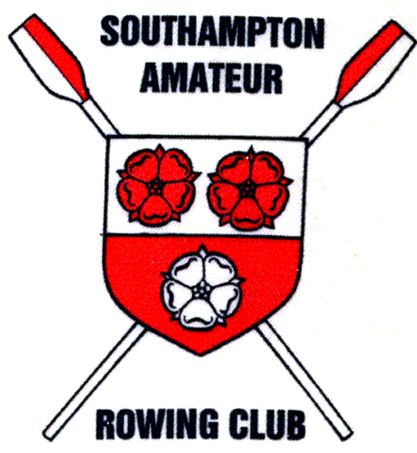
Temporary Membership Application (Under 18)

Temporary Membership Type - please tick: | Fee
- Taster session | £10
- Trial session | £20

Member Details:
Full Name:
Address:
Postcode:
Date of Birth:
Phone (mobile):
Email:

Parent/Guardian Details:
Full Name:
Relationship to member:
Phone (mobile):
e-mail:

In case of an emergency, please provide the name of another person we can contact:
Full Name:
Phone (mobile):

Declarations:
Do you have any medical conditions (eg. asthma, epilepsy) which could affect your safety on the water?  If yes, please give details. | Yes / No
Can you swim 100m in light clothing? | Yes / No
Have you ever been declined membership or asked to leave another club?  If yes, please give details. | Yes / No

General Information:
Trial session lasts for four weeks or until temporary members have had four sessions on the water (usually Sunday mornings).
Temporary members are entitled to attend training nights during the week as part of the trial.
Taster session lasts around 3 hours, during this time temporary members are shown how to use equipment and how to row out on the water.
We recommend temporary members become a British Rowing member for 3 months.

Membership Fees 2022
Adult (18 and over) | £185 + VAT (£37) =£220 | The temporary membership fee is deducted from this amount upon offer of full membership.
University Student (F/T education) | £110 + VAT (£22) = £132
Cadet/VI Form (Under 18) | £85 + VAT (£17) = £102

Signature of parent/guardian:
Date:

Office Use Only:
Trial date:
Payment rec’d Y/N
EC Decision date:
Full Membership date:
Payment date:

